M & M’s: Making Mathematics Meaningful, Motivational, and Mental

Saturday, December 7th

9:00 a.m. – 10:00 a.m.

Trey Cox, Ph.D.

Chandler-Gilbert Community College

[trey.cox@cgc.edu](mailto:treycox@cgc.edu)



























**Classroom/HW Exercise #1**: Many companies that have mail order catalogs charge their customers shipping and handling fees to mail-purchased products. The fees that JC Penney charged in 2017 for their purchases were:

|  |  |
| --- | --- |
| ***t***  **Total Product Cost**  **(Dollars)** | ***S***  **Shipping & Handling Charge**  **(Dollars)** |
| Up to $25.00 | $5.95 |
| $25.01 to $40.00 | $7.50 |
| $40.01 to $50.00 | $8.50 |
| $50.01 to $75.00 | $11.50 |
| $75.01 to $100.00 | $14.95 |
| $100.01 to $150.00 | $18.95 |
| $150.01 to $200.00 | $22.95 |
| $200.01 to $300.00 | $25.95 |
| $300.01 to $500.00 | $29.95 |
| Over $500.00 | $39.95 |

Source: <http://www4.jcpenney.com>

1. What are the shipping and handling charges a customer incurs if the total product cost is $50? $50.01?

2. What are the shipping and handling charges a customer incurs if the total product cost is $562.00? $1000.00?

3. Sketch a graph of the shipping and handling cost,, as a function of the total product cost, , in dollars. Be sure to label and scale the axes appropriately.

4. Write a formula for the shipping and handling cost,, as a function of the total cost, , in dollars.

5. Sketch a graph of the total cost of a purchase including the shipping and handling fee,, as a function of the total product cost ,, in dollars. Be sure to label and scale the axes appropriately.

6. Write a formula for the total cost of a purchase including the shipping and handling fee, , as a function of the total of the product cost, , in dollars.

7. Compare and contrast the graphs of  and . Explain in terms of the real-world context the differences that exist in the graphs.

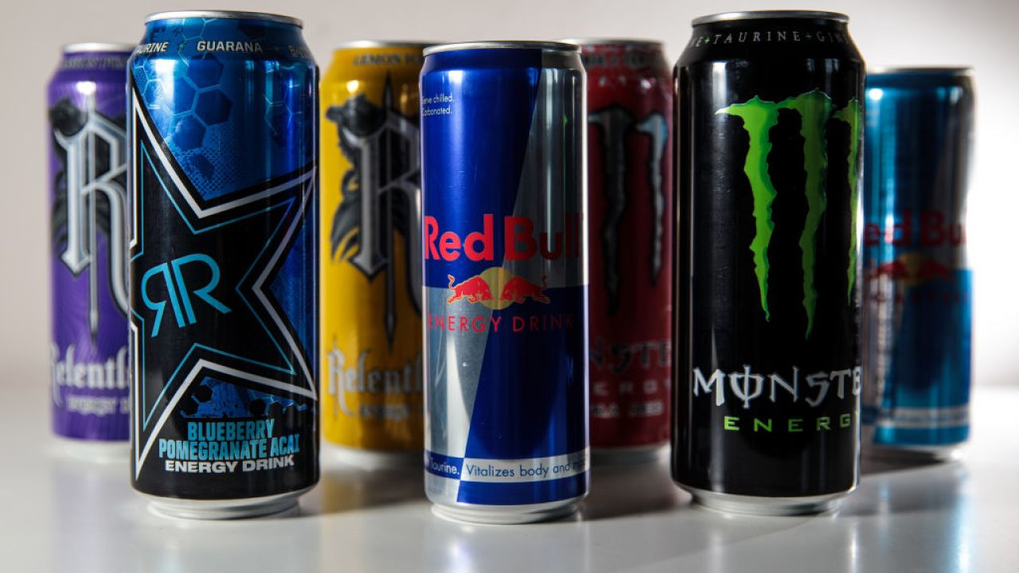**Classroom/HW Exercise #2**: More than 500 new energy drinks were launched worldwide in 2006, each one vying for the dollars of teenagers with promises of weight loss, increased endurance, and legal highs. Newer products joined top-sellers Red Bull and Monster to make up a 3.4 billion dollar-a-year industry that grew by 80 percent in 2005 (Source: ([www.cnn.com](www.cnn.com/)).Most of these beverages are caffeine-laden and nutritionists warn that the drinks can hook people, especially teenagers, on an unhealthy jolt-and-crash cycle. Although energy drinks like Red Bull, Rock Star, Rush, Monster and Hype contain some nutritional vitamins and supplements, many contain other ingredients that are not necessarily good for you. One particular brand of energy drink has 80 milligrams of caffeine in an 8.3 ounce serving can.

The effects of caffeine level in the bloodstream on the heart rate of a typical 175-pound male adult are displayed in the table.

|  |  |
| --- | --- |
| **Caffeine level (mg)**  ***c*** | **Heart rate (beats per minute)**  ***R*** |
| 0 | 80 |
| 50 | 82 |
| 131 | 84 |
| 150 | 85 |
| 198 | 86 |
| 261 | 88 |
| 300 | 89 |

Source: Dr. Brent Alvar, Chandler-Gilbert Community College

Wellness and Fitness Director

It is also known the amount of caffeine in a person’s bloodstream dissipates over time. The amount of caffeine in a 175-pound adult male’s bloodstream would typically dissipate as is shown in the table

|  |  |
| --- | --- |
| **Time (hours)**  ***t*** | **Caffeine level (mg)**  ***C*** |
| 0 | 300 |
| 1 | 261 |
| 2 | 227 |
| 3 | 198 |
| 4 | 172 |
| 5 | 150 |
| 6 | 131 |

Source: Dr. Brent Alvar, Chandler-Gilbert Community College

Wellness and Fitness Director

Using the two tables above, create a table that shows the heart rate, , as a function of the time, .

|  |  |
| --- | --- |
| **Time (hours)**  ***t*** | **Heart rate**  **(beats per minute)**  ***R(c(t))*** |
|  |  |
|  |  |
|  |  |
|  |  |
|  |  |

**Classroom/HW Exercise #3**: The effect of caffeine, , in milligrams (g) on a person’s heart rate, , in beats per minute (bpm) may be modeled by the linear function  and the dissipation of caffeine, , in milligrams (g) from the bloodstream over time, , in hours may be modeled by the exponential function .

1. Form the formula for the composition function . Explain in terms of the real-world context the input and output variables.
2. Graph *r(c), c(t),* and *r(c(t)).* Compare and contrast the three graphs.
3. Evaluate and explain the meaning of your solution in terms of the real-world context.

c. Find the practical domain of , , and .



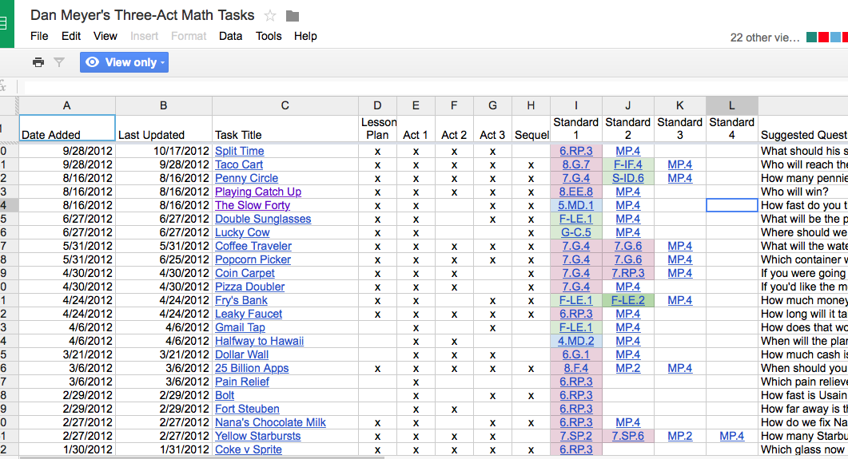







**Team Writing Project Example**:



