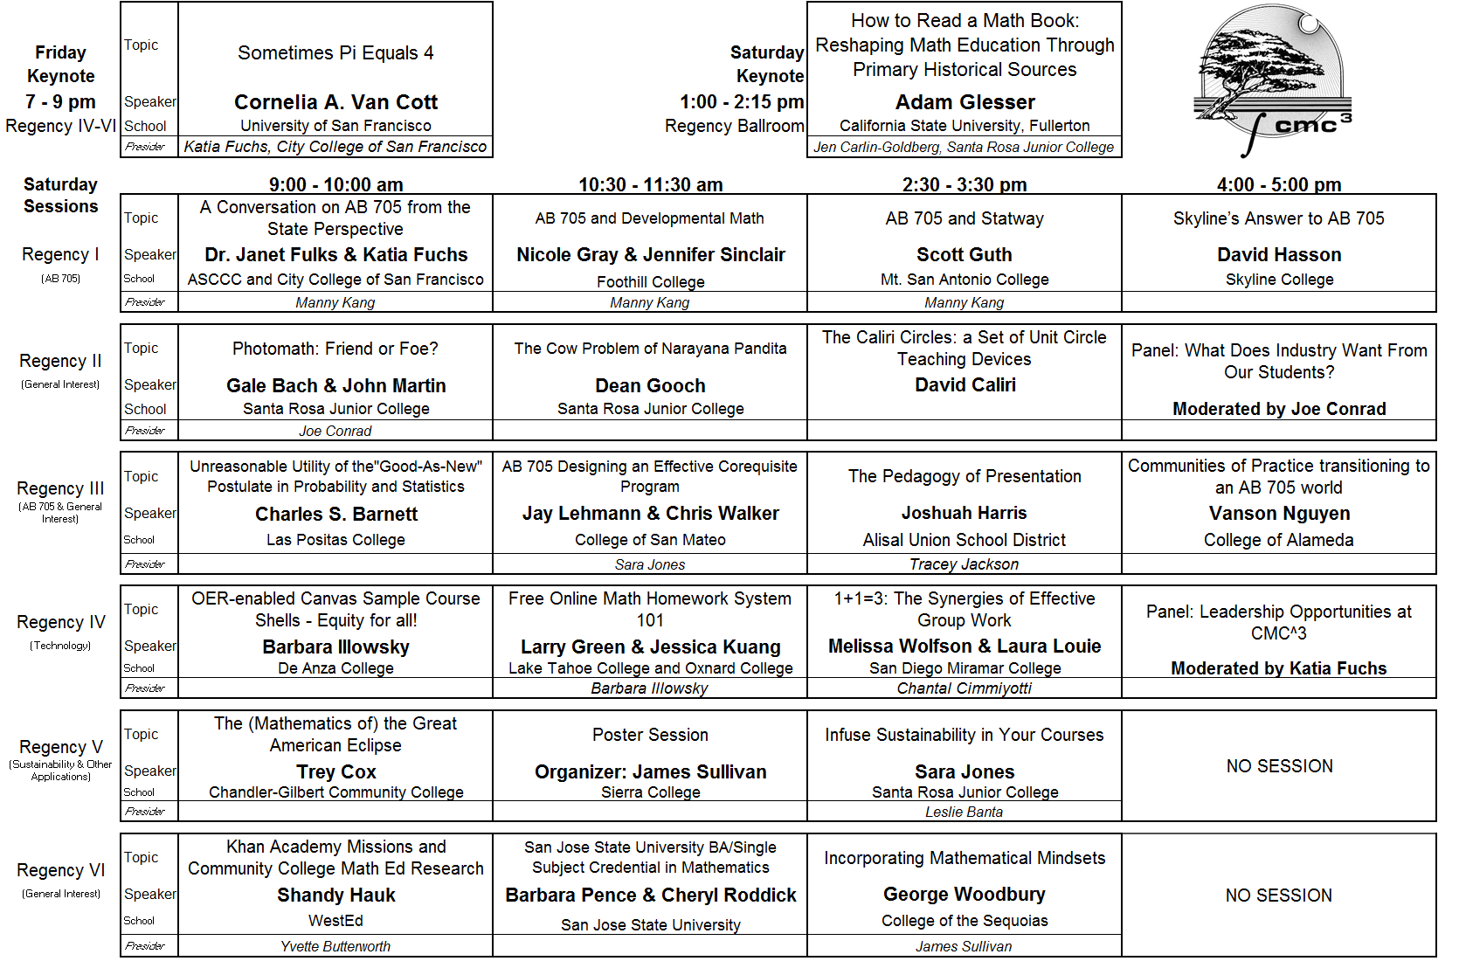

Welcome to the 46th Annual Fall Conference!
The Hyatt Regency Monterey
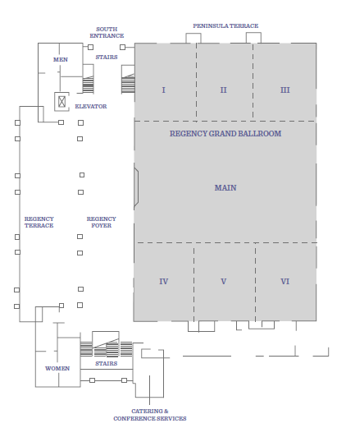

The event organizers are people just like you from various community college mathematics departments across Northern California. We are always looking for more eager volunteers with new ideas. Please consider getting involved with CMC³ by contacting a board member any time. Enjoy the conference!
The California Mathematics Council Community Colleges Foundation annually provides scholarships to honor our mathematics and science students. We need your financial help. We rely on your generosity and donations to fund the Scholarship Program.
Please consider making a donation to our CMC³ Foundation Scholarship Fund. Contributions are tax-deductible, as provided by law. Our tax ID # is 94-3227552.

Please donate in-person at the Foundation table!

CMC³ Board and Conference Committee

President: Katia Fuchs Business Liaison: Dean Gooch
Past-President: Joe Conrad Newsletter Editor: Jay Lehmann*
Pres.-Elect (Conf. Chair): Jennifer Carlin-Goldberg Estimated Walk/Run: Jay Lehmann*
Treasurer: Leslie Banta Student Posters: James Sullivan
Secretary: Tracey Jackson Web Page Manager: Larry Green*
MAA Liaison: Wade Ellis Articulation Breakfast: Steve Blasberg*
Tahoe Speaker Chair: Mark Harbison Foundation President: James Sullivan
A/V Co-chair: Larry Green Foundation Member: Shawn Lanier
A/V Co-chair: Steve Blasberg* Foundation Member: Joe Conrad
Membership Chair: Kevin Brewer Foundation Member: Casey Terrill
*At-Large Board Members

CMC³ Presidents

1973 – 1974 James Curl Modesto Junior College
1974 – 1977 Raymond Wuco San Joaquin Delta College
1978 – 1979 Brandon Wheeler Sacramento City College
1980 – 1981 Hal Andersen Santa Rosa Junior College
1982 – 1983 Art Dull Diablo Valley College
1984 – 1985 Pat Boyle Santa Rosa Junior College
1986 – 1987 Shirley Trembley Bakersfield College
1988 – 1989 Wade Ellis, Jr. West Valley College
1990 – 1991 Denny Burzynski West Valley College
1992 – 1993 Barry Wood Santa Rosa Junior College
1994 – 1995 Debra Landre San Joaquin Delta College
1996 – 1997 Chris Burditt Napa Valley College
1998 – 1999 Michael Eurgubian Santa Rosa Junior College
2000 – 2001 Lois Yamakoshi Los Medanos College
2002 – 2003 Randy Taylor Las Positas College
2004 – 2005 Rick Hough Skyline College
2006 – 2007 Rob Knight Evergreen Valley College
2008 – 2009 Larry Green Lake Tahoe Community College
2010 – 2011 Barbara Illowsky De Anza College
2012 – 2013 Susanna Gunther Solano Community College
2014 – 2015 Mark Harbison Sacramento City College
2016 – 2017 Joseph Conrad Solano Community College
2018 – Present Katia Fuchs San Francisco City College

Past CMC³ President's Awardees (selected by the CMC³ President)

2002 Barry Wood Santa Rosa Junior College
2003 Chris Barker De Anza College
2004 Noelle Eckley Lassen College
2005 Barbara Illowsky De Anza College
Zwi Reznik Fresno City College
2006 Sandi Nieto Santa Rosa Junior College
2007 Randy Taylor Las Positas College
2008 Mark Harbison Sacramento City College
2009 Jim Spencer Santa Rosa Junior College
2010 Robert Knight Evergreen Valley College
2011 Larry Green Lake Tahoe Community College
2012 Michael Eurgubian Santa Rosa Junior College
2013 Ken Seydel Skyline College
2014 Rebecca Fouquette De Anza College
2015 Jay Lehmann College of San Mateo
2016 Leslie Banta Mendocino College
2017 Larry Green Lake Tahoe Community College

Past CMC³ Distinguished Service Awardees (selected by the CMC³ board)

1992 Ray Wuco San Joaquin Delta College
1993 Frank Denney Chabot College
“ Wade Ellis, Jr. West Valley College
“ Brandon Wheeler Sacramento City College
1994 Patrick Boyle Santa Rosa Junior College
“ Arthur Dull Diablo Valley College
1995 Hal Andersen Santa Rosa Junior College
“ Sister Clarice Sparkman San Jose City College
1996 James Curl Modesto Junior College
1997 Guy De Primo City College of San Francisco
1998 Allen Utterback Cabrillo College
1999 Barry Wood Santa Rosa Junior College
2000 Denny Burzynski West Valley College
2001 Chris Burditt Napa Valley College
2002 Wei Jen Harrison American River College
2003 Marilyn McBride Skyline College
2004 Michael Eurgubian Santa Rosa Junior College
2005 Lois Yamakoshi Los Medanos College
2006 Debra Landre San Joaquin Delta College
2007 Dave Johnson Diablo Valley College
2008 Chris Barker De Anza College
2009 Rick Hough Skyline College
2010 Jim Spencer Santa Rosa Junior College
2011 Randy Taylor Las Positas College
2012 Cynthia Speed Mendocino College

Past CMC³ Distinguished Service Awardees (continued)
2013 Rob Knight Evergreen Valley College
2014 Barbara Illowsky De Anza College
2015 Noelle Eckley Lassen Community College
2016 Debbie VanSickle Sacramento City College
2017 Susanna Gunther Solano Community College
2018 – Rebecca Fouquette
I had the privilege of serving with Rebecca on the CMC³ board where she served as treasurer for several years and started the student poster contest. Rebecca started her love affair with teaching math back in the 6th grade when she began tutoring her peers. By 8th grade, she was tutoring for pay. After attending Cal Poly, San Luis Obispo and receiving a BS in mathematics, BS in statistics and a MS in mathematics, Rebecca started teaching high school while working on her single subject credential at San Jose State. After two years, she moved to Santa Rosa JC, her favorite job to date. She had a wonderful four years with the staff and students, but you can’t control life and life said she was moving! She found a new home at De Anza College and stayed there for three years. Rebecca has returned to her first love, working with students one-on-one.
She now bakes for her excellent online bakery From Pie to Infinity and privately tutors in the San Jose area. Thank you for your dedicated service, Rebecca!

CONFERENCE PROGRAM - FRIDAY

4:30 – 6:30 pm Registration Regency Foyer

5 – 6:30pm Statistics – Then and Now Regency IV-VI
Join us as George Woodbury (College of the Sequoias, Pearson Author) shares his thoughts on “Statistics – Then and Now.” Among the topics will be creating an active learning environment, effective use of technology, early introduction of inferential techniques, and new inferential techniques (randomization, resampling, simulation, bootstrapping). There will be time for questions and answers.

CONFERENCE PROGRAM – FRIDAY (Continued)

7:00 - 8:00 pm Dessert Reception Regency IV - VI
8:00 - 9:00 pm Keynote Regency IV - VI
Dr. Cornelia A. Van Cott, University of San Francisco
cvancott@usfca.edu
Sometimes Pi Equals 4
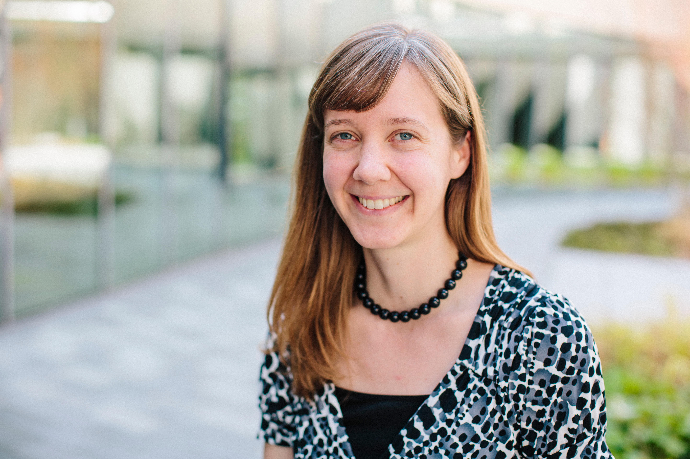
Most of your mathematical life, you have known that pi is an irrational number somewhere between 3.1 and 3.2. But if we exchange the usual Euclidean norm for another norm, the geometry of the plane changes, including a change in the shape of circles and the associated value of pi. From this new vantage point, pi can be any of an infinite number of different values. What are these values? What does a pi-value indicate about its associated norm and vice versa? We will observe several surprising twists and turns and find interesting questions that are yet unanswered.

9:00 pm – Midnight Regency IV - VI
Game Night!
Friday evening is for of games, puzzles, and other activities. There will be hors d'oeuvres and a No-Host Bar. Thank you Cengage for your help in putting on this event! Join us for food, conversation, and fun!

CONFERENCE PROGRAM - SATURDAY
7:20 am Estimation Walk/Run Meet by the Front Desk
8:15 am – 10:00 am Registration Regency Foyer
8:30 am – 1:00 pm, Exhibits open Regency Foyer
2:00 pm – 5:15 pm

First Session: 9:00 - 10:00 am

Regency I (AB 705)
Dr. Janet Fulks & ASCCC & jfulks@bakersfieldcollege.edu
Katia Fuchs City College of San Francisco efuchs@ccsf.edu
A Conversation on AB 705 from the State Perspective
An update on AB 705 from the state level and on any other legislation coming down the pipe. Janet will be joined by Katia, both of whom are on the Implementation Committee, and will be there to answer questions on AB 705.

Regency II (General Interest)
Gale Bach & Santa Rosa Junior College gbach@santarosa.edu
John Martin Santa Rosa Junior College jmartin@santarosa.edu
Photomath: Friend or Foe?
The free app Photomath can solve many textbook problems and its latest version can also recognize handwriting. The app not only gives an answer, but it also shows the steps in the solution process. Your students know about Photomath, do you? Join us for a lively debate on the pros and cons.

Regency III (General Interest)
Charles S. Barnett Las Positas College cjbarnett2@comcast.net
Unreasonable Utility of the"good-as-new" Postulate in Probability and Statistics
You are put on hold, and it seems that no matter how long you have waited, the chance you will have to wait another minute, say, hardly changes. There is an “App” (well, a probabilistic model) for that. And that model shows up in many practical, important, and disparate fields. Exponentially distributed, and only exponentially distributed, random variables have the relevant property. The solution of a simple functional equation establishes the property.

Regency IV (Technology & OER)
Barbara Illowsky De Anza College illowskybarbara@fhda.edu
OER-enabled Canvas Sample Course Shells - Equity for all!
Students need access to required course materials on Day 1 of the course to increase their likelihood of success. Providing free access to these materials is an effective way to provide student equity, lower the academic achievement gap, and increase student success. The OEI developed 30 OER-enabled Canvas sample course shells. These ADA accessible shells are aligned to the OEI design rubric.

First Session: 9:00 - 10:00 am, continued
Regency V (Sustainability/Environment)
Trey Cox Chandler-Gilbert Community College trey.cox@cgc.edu
The (Mathematics of) the Great American Eclipse
The solar eclipse of August 2017, dubbed "The Great American Eclipse" by the media, was a total solar eclipse visible within a band that spanned the entire contiguous United States, passing from the Pacific to the Atlantic coasts. This session will be a hands-on classroom-ready activity investigating the mathematics thereof.

Regency VI (Education)
Shandy Hauk WestEd shauk@wested.org
Khan Academy Missions and Community College Math Ed Research
Over the last two years, dozens of instructors and hundreds of their students participated in a study of the use of Khan Academy in California community college algebra classes. The presentation provides findings about what works, for whom, under what conditions through three different examples of implementation and results.

Reminders:  8:30 am - 1:00 pm and 2:00 pm - 5:15 pm  Exhibits open  Regency Foyer  9:30 am - 1:00 pm  Student Posters on Display  Regency Foyer | 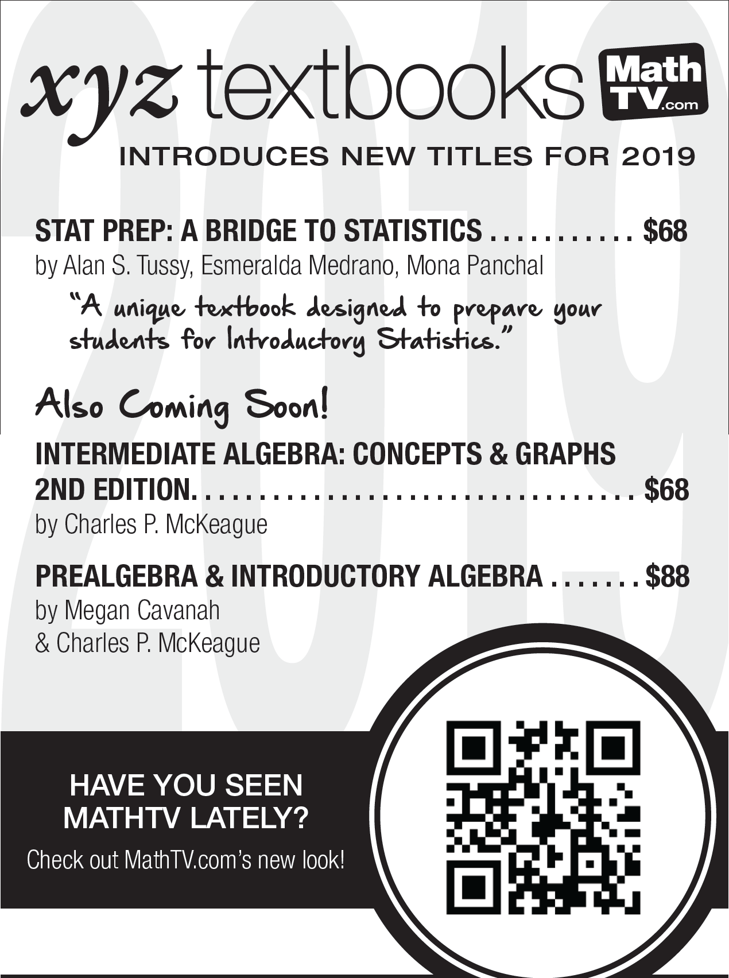
The American Mathematics Association of Two-Year Colleges (AMATYC) will hold their next annual conference in Milwaukee, WI on November 14-17, 2019.
Conference Theme:
Great Lake - Great Ideas!

Second Session: 10:30 - 11:30 am
Regency I (AB 705)
Nicole Gray & Foothill College graynicole@foothill.edu
Jennifer Sinclair
AB 705 and Developmental Math
Speakers will discuss Foothill College’s adoption of a developmental level Quantitative Reasoning course as a part of the department curriculum choices to address AB 705. The discussion will include rationale for development of such a course and describe the path to department approval.
Regency II (General Interest)
Dean Gooch Santa Rosa Junior College dgooch@santarosa.edu
The Cow Problem of Narayana Pandita,
a Fibonacci-like Problem from Fourteenth Century India
The Cow Problem of Narayana Pandita involves the growth of a cow population over twenty years. These cows are able to have their own female calves in the fourth year of their life. I will investigate the series solution used to solve this problem by fourteenth century Indian mathematicians and look into finding a recurrence relation to solve this problem. Extensions of this problem will also be examined.
Regency III (AB 705)
Jay Lehmann & College of San Mateo mathnerdjay@aol.com
Chris Walker College of San Mateo walkerc@smccd.edu
Designing an Effective Corequisite Program
This fall, College of San Mateo (CSM) eliminated its arithmetic and elementary algebra courses and introduced corequisite intermediate algebra and prestatistics. CSM will add corequisite statistics in Spring 2019 and corequisite precalculus and applied calculus in Fall 2019. Come hear about this program, which includes in-class tutors and counselors. We will also discuss how to train faculty to facilitate group learning, which is an essential part of the program. Finally, we will discuss how to design affective domain activities as well as low floor high ceiling activities that challenge and engage students, no matter what their ability.

Regency IV (Technology & OER)
Larry Green & Lake Tahoe Community College drLarryGreen@gmail.com
Jessica Kuang Oxnard Community College jkuang@vcccd.edu
Free Online Math Homework System 101
We will present ready to use online homework templates for most mathematics courses. The platform is MyOpenMath, and the homework questions have been created by a community of math instructors. We will give an orientation of MyOpenMath, preview the templates, and demonstrate how to use them. Included will be Canvas integration and how to customize the course settings.

Regency V (Student Posters)
Moderator: James Sullivan Sierra College jsullivan@sierracollege.edu
Student Poster Presentations
In this session, students will present their posters for the Student Poster Contest. Please come and support our students!

Second Session: 10:30 - 11:30 am, continued
Regency VI (Education)
Barbara Pence & San Jose State University Barbara.Pence@sjsu.edu
Cheryl Roddick San Jose State University cheryl.roddick@sjsu.edu

Find out about the NEW San Jose State University 4 YEAR Integrated
BA/Single Subject Credential in Mathematics
Beginning in the fall 2018, the department of Mathematics at San Jose State University will offer the first 4-year undergraduate program in California to provide a BA in Mathematics and a preliminary Single Subject credential in Mathematics. Join us to explore the opportunities this program offers for interested Community College.

11:45 am - 12:30 pm Buffet (tickets required) Regency Main

Luncheon: 11:45 am - 12:30 pm
(Mention to one of the servers if you have special dietary needs not met by the buffet.)

General Session: 12:30 - 2:15 pm

12:30 - 1:15 pm Poster awards, CMC³ awards Regency Main
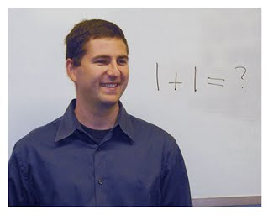
1:15 - 2:15 pm Keynote Regency Main
Dr. Adam Glesser
California State University, Fullerton
adamglesser@gmail.com
How to Read a Math Book: Reshaping Math Education Through Primary Historical Sources
Students in math classes frequently work under the assumption that reading is unnecessary since the instructor will explain everything in class. Meanwhile, instructors work under the assumption that their students won't (or can't) read and hence feel duty bound to explain everything in class. As long as everybody understands their role in this game of passive education, the students remain generally happy pretending to learn, and the teachers cringingly continue moving through content that they correctly conclude their students do not comprehend. In this talk, we explore what happened when several instructors decided to change the rules of the game, teaching the students how to read mathematical texts, and then requiring students to actually do it! In addition to summarizing the method, there will be lots of examples of successes and failures, links to an abundance of resources, and a case made that mathematics, as a student discipline, needs to recapture its role as a liberal art rather than a mechanical one.

2:00 - 5:15 pm Exhibits open Regency Foyer

Third Session: 2:30 - 3:30 pm

Regency I (AB 705)
Scott Guth Mt. San Antonio College sguth@mtsac.edu
AB 705 and Statway
The speaker will discuss efforts to adapt the Statway Curriculum to the requirements of AB 705. The discussion will cover the Chancellor’s current view of how Statway fits under the new guidelines, and how developers are working to make it work for a larger population of students.

Regency II (General Interest)
David Caliri Caliri Circles davidcaliri@gmail.com
The Caliri Circles: a Set of Unit Circle Teaching Devices
The unit circle can be redone and exalted to such an echelon that it is analogous to the central role that the periodic table plays in chemistry. This session presents the unit circle through many mathematical perspectives by a series of circles in generalized geometries subjected to various

Regency III (Education)
Joshua Harris Alisal Union School District josh@edtechspec.org
The Pedagogy of Presentation
Tired of the same old cookie cutter, read-off-the-slide of student presentations? Feeling like your own presentations or slides-based lessons could be more engaging? Good presentations like good writing, are good by design. In this session we will look at some foundational yet flexible structure and design ideas following the “creative constraint” concept which will help teachers approach teaching presentations similarly to how they approach teaching writing. We will discuss, get and learn how to make templates that produce good presentations, not the same one over and over. We will look at how to Google Slides can help leverage imagery with photo editing tips and tricks, and how Google Forms and other tools can increase audience interactivity and critical listening and thinking to make student (and teacher, and administrator) presentations engaging and powerful. Good for any discipline.

Regency IV (Education)
Melissa Wolfson & San Diego Miramar College mwolfson@sdccd.edu
Laura Louie San Diego Miramar College llouie@sdccd.edu
1+1=3: The Synergies of Effective Group Work
Learn, share, and develop effective strategies for facilitating group work in math classes. We will discuss what works, what doesn’t, and how to creatively modify strategies to fit your individual teaching style!

Third Session: 2:30 - 3:30 pm, continued
Regency V (Sustainability/Environment)
Sara Jones Santa Rosa Junior College sjones@santarosa.edu
Infuse Sustainability in Your Courses
Sustainability can encompass a large scope of topics including economic, environmental, and social equity issues. These questions are important to our students and our society. They help engage students and provide interesting examples in any mathematics course. Come find out how you can make your mathematics course into a course that includes sustainability.

Regency VI (Statistics)
George Woodbury College of the Sequoias georgew@cos.edu
Incorporating Mathematical Mindsets
There has been a great deal of research into the advantages of having a growth-mindset over a fixed-mindset. These ideas can have a positive impact on your students and their performance. Come learn about the two mindsets and how to help students develop a growth mindset.

 | CMC³ Needs You!  Volunteers are the lifeblood of CMC³  CMC³ has a long tradition of supporting Community College Math faculty and students.  There are many ways that you can give back by joining the CMC³ Board or volunteering in other ways.  For more information on how you can become involved, please head to:  http://www.cmc3.org  Or contact Katia Fuchs at efuchs@ccsf.edu |  | 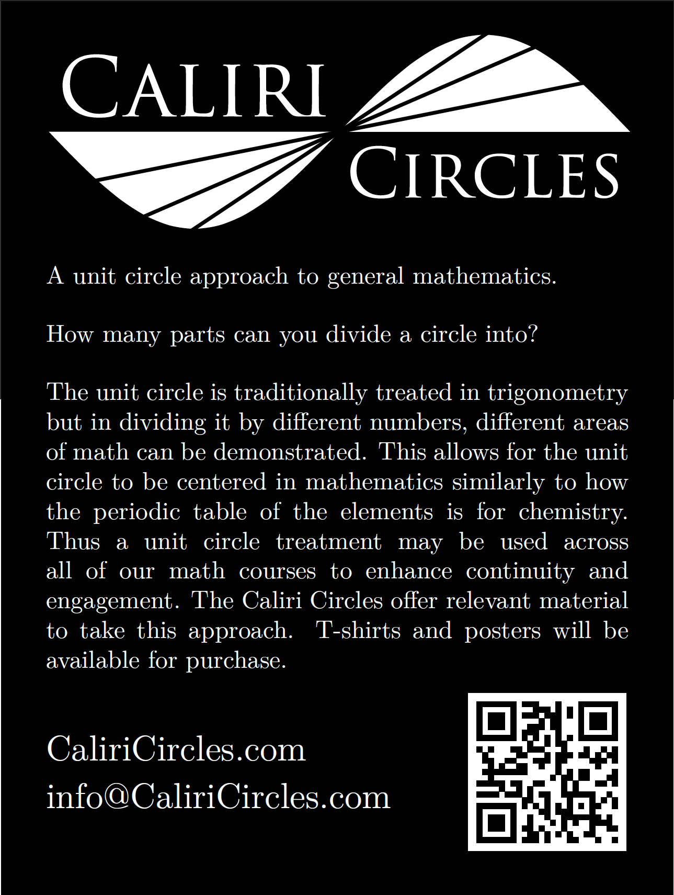
SPECIAL THANKS TO ...  * Santa Rosa Junior College  [printing and postage]  * AMATYC  [tote bags]  * XYZ Textbooks  [program printing]  * Cengage  [Friday "Game Night"]  * Our Pearson pre-conference presenter:  George Woodbury: “Statistics – Then and Now.”  * All of our Door Prize and Foundation Donors!  Thanks to our Exhibitors!  CMC³ Foundation Cengage  Hawkes Learning Pearson Education  Caliri Circles XYZ Textbooks  WestEd |  | 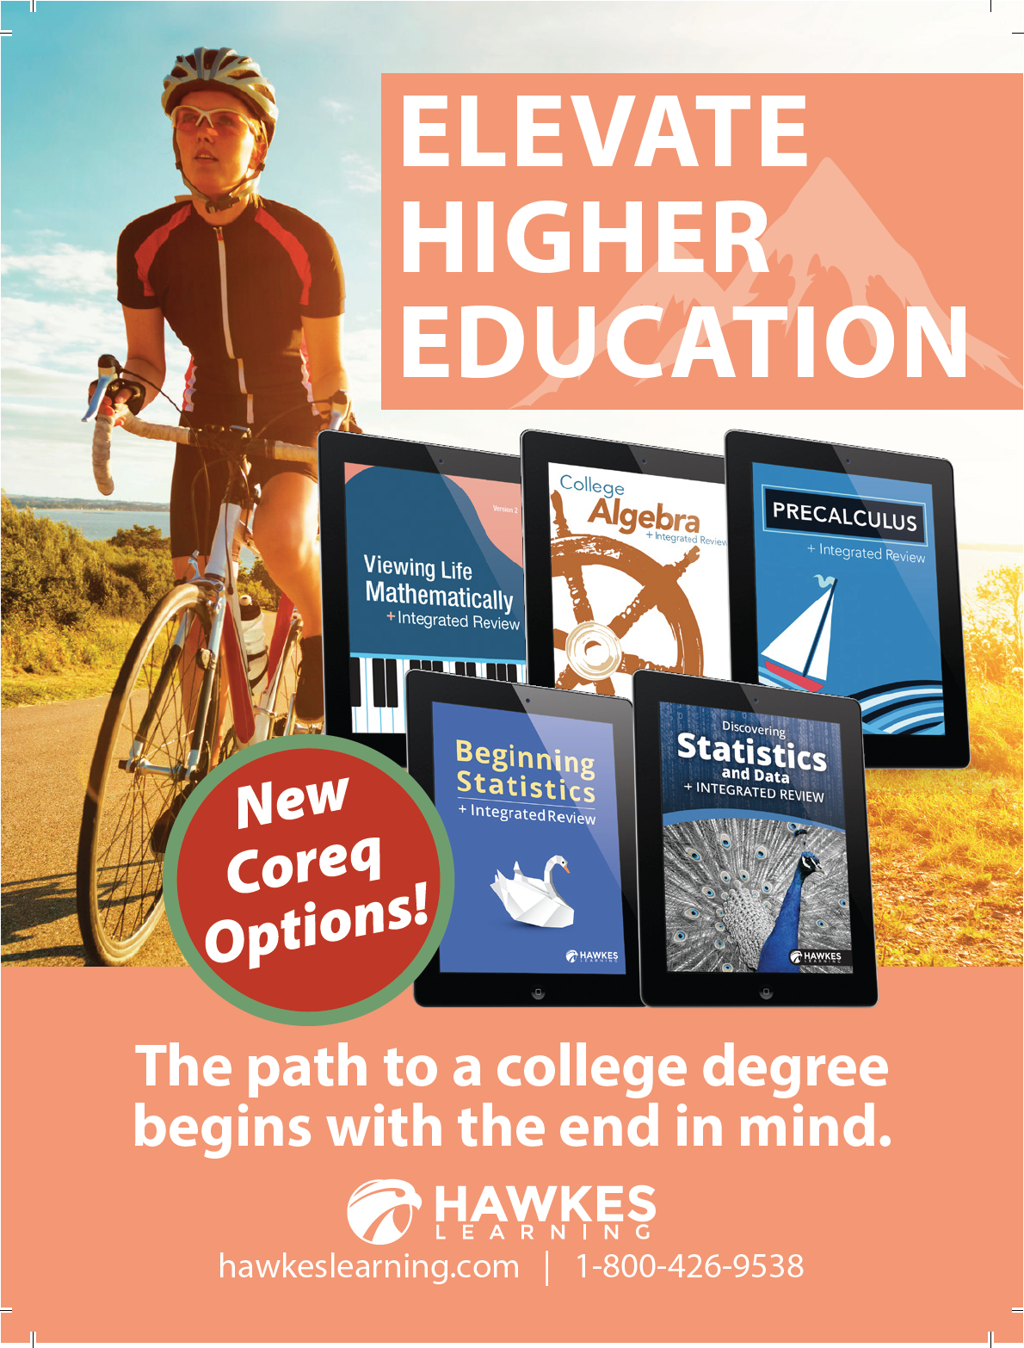
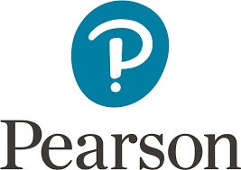
Come by the Pearson booth to learn
more about resources for AB 705
redesign
Our Integrated Review MyMathLab & MyStatLab courses provide both the
college course content as well as the remediation course content
Ask us about our personalized learning
& pre-built courses for California
Community Colleges at the special
discounted price
www.pearsonhighered.com

Fourth Session: 4:00 - 5:00 pm
Regency I (General Interest)
David Hasson Skyline College hassond@smccd.edu
Skyline’s Answer to AB 705
Let us explore and discuss the bicycle we’re building and our attempts to ride it mid-construction.
Regency II (Issues and Panel)

What Does Industry Want From Our Students?
Employers want graduating students to be able to do math, but what specifically are they looking for from people that they hire? What can we focus on as instructors to better prepare our math students for jobs on the outside? Join our panelists: Julia Harberson, Civil Engineer with CSW/Stuber-Stroeh Engineering Group, Inc., Dima Kuzman, Google Software Engineer, and Sonya Berg, Data Scientist at Stitch Fix. Moderated by Joe Conrad, Solano Community College.

Regency III (AB 705)
Vanson Nguyen College of Alameda vansonnguyen@peralta.edu
Communities of Practice: Transitioning to an AB 705 World
With the new mandates coming down from the state, there is opportunity to provide support for faculty and transform classrooms. In this workshop, participants will learn about Communities of Practices at one college. Different participation structures, facilitation strategies and activities will be highlighted to display a wide range of possibilities for faculty looking to develop Communities of Practice at their own institutions.

Regency IV (Leadership)
Moderator: Katia Fuchs City College of San Francisco efuchs@ccsf.edu
Leadership Opportunities at CMC^3
CMC^3 is an organization that supports Community College Math faculty and students. CMC^3 serves the role of informing and advocating on behalf of faculty specifically on curricular and pedagogical issues. We partner with organizations like CMC3 South and the State Academic Senate. We run two conferences every year, we advocate on community college Math issues at the State level, and much more. Many people are needed to make all of this happen. Come join the President of CMC^3 and other members of the Board and Foundation to hear about all of the opportunities to participate in the organization and to help students!

5:00 – 6:00 pm Foundation Drawing Regency Foyer
6:00pm – Midnight Free shuttle downtown Conference Center Entrance

Mark Your Calendar!

CMC³ 23rd Annual Recreational Mathematics Conference
Fri., April 26 to Sat., April 27, 2019
Lake Tahoe Community College

~NOTES~

~NOTES~

