MY Pathway, MY Future – Guided Self Placement
This brief sheet will help you consider what you would like for you future and educational planning. Please fill in the form below as you look at the Guided Self Placement Information on the web. Take this sheet into a counselor in order to prepare for the upcoming coursework and program you choose.
Information/Questions | Your answers
- Name
- Age
- What career(s) are you currently interested in and why? | 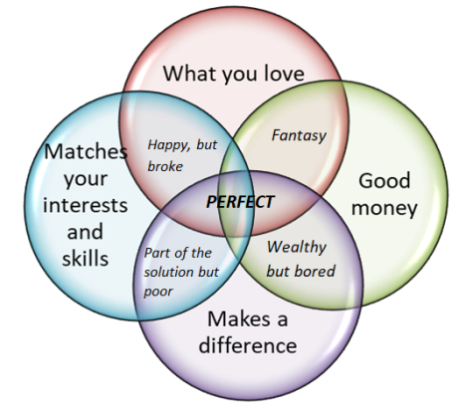
- How confident are you in this selection of career? | - Very confident  - Somewhat confident in the choice for now  - Need further exploration  - Currently not sure and cannot make a choice
- Based on the general areas of interest or metamajors, select the area below you are most interested in. If you are unsure or have two choices select your second choice in the next question.  Indicating a general area here is important in determining the math/quantitative reasoning course you will need. | - STEM (Science, Technology, Engineering, Math, Computer Science, etc)  - Business, Accounting, Economics  - Education  - Behavioral or Social Sciences (Psychology, Sociology, Public Safety, Communication, Allied Health, Human Resources, Journalism)  - Arts and Humanities (English, Philosophy, Communication, History, Art, Theater, etc)  - Technical Majors (such as Automotive, Electricity, Culinary Arts, Hospitality, Costuming, Welding etc)  - Allied Health Fields (Medicine, Nursing, Radiology, Pharmacy, Physical Therapy, Athletic Training, Dental Hygiene, Respiratory Therapy, etc)  - Don’t know yet
- Do you have a second area of interest? | - STEM (Science, Technology, Engineering, Math, Computer Science, etc)  - Business, Accounting, Economics  - Education  - Behavioral or Social Sciences (Psychology, Sociology, Public Safety, Communication, Allied Health, Human Resources, Journalism)  - Arts and Humanities (English, Philosophy, Communication, History, Art, Theater, etc)  - Technical Majors (such as Automotive, Electricity, Culinary Arts, Hospitality, Costuming, Welding etc)  - Allied Health Fields (Medicine, Nursing, Radiology, Pharmacy, Physical Therapy, Athletic Training, Dental Hygiene, Respiratory Therapy, etc)  - Don’t know yet
- How confident are you in your choice of an ultimate educational goal? | - Very confident  - Somewhat confident in the choice for now  - Need more exploration  - Cannot make a choice and need some more information
- Select your ultimate, realistic educational goal. | - Obtain an AA/ADT & Transfer to a four year institution  - Transfer without a degree  - Obtain an AA without transfer  - Obtain a certificate without transfer  - Explore new options, interests goals, prepare for a new career  - Advance in my current job – skills builder  - Maintain a license or certification  - Complete HS or GED  - Improve Basic Skills  - Currently enrolled in 4 year institution taking requirements for that institution  - Undecided/Exploring
- How confident are you in your choice of an ultimate educational goal? | - Very confident  - Somewhat confident in the choice for now  - Need further exploration  - Not sure of my ultimate education goal at this point  - May change my ultimate goal later but I am committed to this goal for now
- Indicate your High School GPA (unweighted) for the last year completed. You will need to bring your transcript to your appointment with your counselor to look at the courses you took. | - 3.6-4.0  - 3.0-3.59  - 2.6-2.99  - 2.3-2.59  - 2.0-2.29  - 1.5-1.99  - Less than 1.49  - I do not know my High School GPA
- Which of the following is true of this GPA? | - Cumulative through Senior (4th) year  - Cumulative through Junior (3rd) year  - GPA from another country  - I have no records of my high school GPA
- English and ESL courses.  Check all that apply. | - I completed all 4 years of high school English  - I took and passed the ERWC (English Reading and Writing Course)  - I have taken ESL courses.  - I passed all my English and or ESL courses  - I did not pass all of my English and ESL courses.
- Math courses | What was the highest math course you took and what was your grade? (Examples in increasing order of might be arithmetic, pre-algebra, algebra, algebra 2 or intermediate algebra, geometry, trigonometry, pre-calculus, statistics, calculus). Later we will ask about AP (advanced placement) courses.
- Additional factors | Check any of the following factors that apply:  - AP courses  - AP test scores over 3  - CLEP test scores  - Military experience  - Work experience
- What general education pattern will you take? | - Local general education – required for local degrees only  - CSU breadth for all ADT and CSU transfer  - IGETC – for UC and CSU transfer  - ScIGETC for certain high unit STEM programs at CSU and UC  - I do not know I need help understanding the general education options and requirements
- English/ESL and you  What you write will not be used to place you into a particular course or to evaluate your skills. This is a self-reflection and you are encouraged to be positive. Include the kind of support, if any, you will participate in. | Write a sentence or two about your own confidence and ability to meet college level writing and research outcomes.
- Look at the course work available for English and/or ESL.  Select a course. | After looking at the English/ESL courses available, the unit and time commitment and success data, please write down the one you feel is best for you and why. Include any questions, concerns or issues?
- Math/Quantitative Reasoning and You  This information will not be used to place you into a course or major, it is a self-reflection and you are encouraged to be positive. Include the kind of support, if any, you will participate in. | After reviewing your history with math coursework and other experiences, write a sentence or two about your confidence and direction with regards to math and quantitative reasoning.
- Look at the course work available for Math/Quantitative Reasoning.  Select a course | After looking at the math/quantitative reasoning courses related to various areas of interest as well as the number of courses, units, time commitment and success data, please write down the one you feel is best for you and why. Include any questions, concerns or issues?

Any thoughts or questions you would like to discuss?

Take this information and your transcript to your counseling appointment.
Likelihood

